Hangman Hills Residents Listing

Created on [date]

Registrants to date: [number]

Instructions for creating a hard, formatted copy of the registrants listing, using Microsoft Word.

BE SURE TO DELETE THESE INSTRUCTIONS WHEN DONE, BEGINNING WITH “Instructions for creating a hard, formatted…” AT THE HEAD OF THIS SECTION, DOWN TO AND INCLUDING THE LINE FOLLOWING “…date in the format, YYYYMMDD”.

- From the Residents page on the HHRA website, highlight and copy (ctrl + c) the complete listing from the HHRA Residents Directory (all the text in the light-yellow listing area of the table)
- Highlight the current listing below, beginning with the first letter of the first record, and then replace it by pasting (ctrl + v) the new data. If this is the first use of this template, then the data section is represented by the words, RESIDENTS LISTING GOES HERE. If you highlight ONLY the text, “Residents Listing Goes Here”, then you’ll be golden—the list’s column formatting will remain as needed. Otherwise, your actions may undo the list’s special formatting, which might make the list look a bit weird, and you’ll need to reformat the list as described later.
- If desired, fill in the Created on [date] and Registrants to date [number] fields. Otherwise, they may be selectively deleted.
- For the page layout, click anywhere and then:
  - In the main menu, select: Layout Margins Narrow
- If necessary or desired, the list’s formatting may be modified and/or reset as follows. For the list, only, highlight all the records within the list section and then set the following formatting:
  - Right click anywhere inside the fully highlighted listing section and select Font… Size: 12
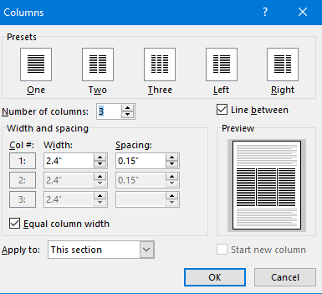
  - With the section still fully highlighted, verify the correct column layout. HINT: navigate to Layout Columns More Columns. There, it will list the section layout, which should be as shown below:
  - For the final formatting “tweaks”, with the section still fully highlighted, right click anywhere inside the fully highlighted section and select Paragraph… and perform the following edits:

Spacing Before: leave blank. If you set any value in this field, you cannot subsequently undo the blank. In this case, press ctrl + z to undo the prior action and then try again.

Spacing After: 0pt

Line spacing: single
- If the first record appears to be shifted down, then FOR THE FIRST LINE IN THE FIRST RECORD, ONLY, set the spacing Before to 0pt
- Once you have produced the listing, you should delete these instructions as prior described. NOTE: you should save your new listing TO YOUR LOCAL COMPUTER with a different file name. Suggest something like this: HangmanHillsResidentsListing20181020, where the suffix represents the date in the format, YYYYMMDD.

RESIDENTS LISTING GOES HERE

